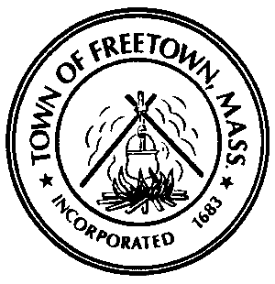 | TOWN OF FREETOWN  TOWN HALL • P. O. BOX 438 • ASSONET, MASSACHUSETTS 02702

Notice of Vacancy
Scholarship Committee

Notice is hereby given that a vacancy exists for one member on the Scholarship Committee for a three-year term beginning July 1, 2023 and expiring June 30, 2026.

The Scholarship Committee meets on an as-needed basis, typically two-to-three times each year. When funding allows, the committee solicits applications from Freetown high school seniors and awards scholarships based on financial need, academic performance, and extra-curricular/volunteer activities.

Applicants for this vacancy must be residents of Freetown.

Anyone interested in serving on this committee is asked to send a letter of interest to the Board of Selectmen at the Town Hall, P. O. Box 438, Assonet, MA 02702 or via e-mail at lsouza@freetownma.gov.

